MEDIA RELEASE: 25 July 2021
For immediate release - crowdfunding campaign runs to 30 July (5 days to go)
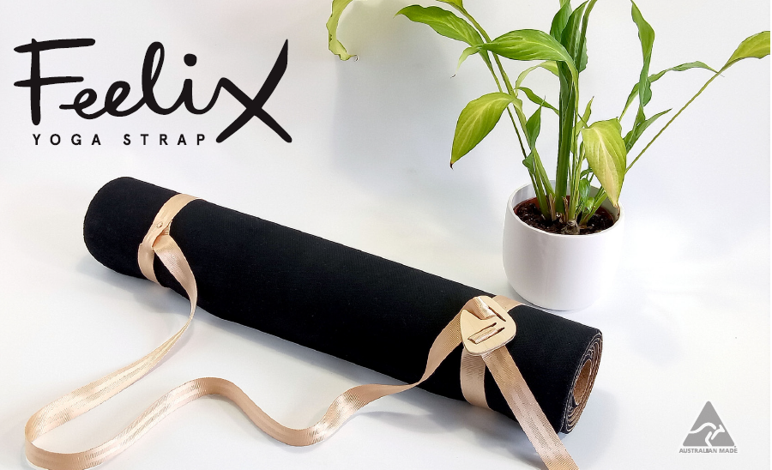

Feelix Yoga Strap: Take the Zen from Class to Home.
A Sustainable Answer to Transporting Your Mat.

Your yoga mat is meant to be a place of Zen. A place of working things out. The home of Savasana. But as all yogis know, the awkward juggle of getting your mat home, can be anything but a smooth flow.
This is where Feelix Yoga Strap comes in.
Designed by Melbourne Yoga teacher Jen Paynter and made from sustainable materials, the Feelix Yoga Strap effortlessly attaches to backpacks and bikes or over the shoulder for a smooth transport to and from class, while doubling as a classic yoga stretching strap.
Tested over two years, through Melbourne’s tough weather conditions and with over 1000 hours on the shoulders of yogis, the Feelix Yoga Strap has been put through its paces and is ready to go.
On its inception, Jen Paynter said, “My main form of transport is a bicycle. Melbourne may be the most liveable city, but it is not the most bike friendly.
With a backpack and mat over your shoulder that falls every time you indicate you realise pretty quick you have a problem that needs solving if you’re going to get to yoga in one piece.”
A year and hundreds of discarded ideas and designs later. She is excited to be sharing her answer to tackling this travel issue.
“In this new Covid-safe world, the studio’s yoga mats sitting in the corner have become a far less appealing option. More and more, yogis are buying their own mats for class and the Feelix strap makes getting it to the studio a breeze.
For those who enjoy home practice, the strap encourages deep Yin-style stretching, perfect for working out the kinks that come with sitting at your computer all day.”
Responsibly designed and handmade with local materials, the Feelix straps are currently only made to order in limited numbers.
Head here for more Feelix info and here to purchase your own.

For media or interview opportunities, please reach out to Jen at: 0413387081 hello@108yogaroad.com

Images available through
www.108yogaroad.com/media

Campaign
https://www.liftwomen.com/projects/feelix-yoga-strap-the-flexible-carry-and-stretching-strap/

