MEDIA RELEASE: June 2021
For immediate release - Kickstarter campaign live
-------------

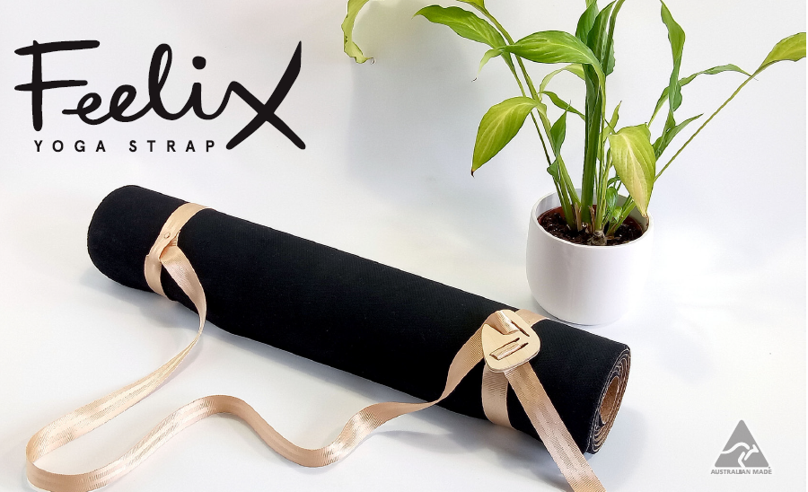

Take your yoga kit up a notch
A new concept in yoga straps set to get the industry moving.

If you’ve ever struggled to keep your yoga mat under control getting it to or from class. Yoga teacher and entrepreneur Jen Paynter of 108 Yoga Road has the solution for you.
Her design the Feelix Yoga Strap is an elegant piece of craftsmanship that functions as a classic yoga stretching strap but also a carry strap. In a design first, it uses the mat stickiness to grip. Then held in place by a notched wooden lock in any one of a variety of configurations depending on how the user travels. It’s both simple and clever.
As with all good products it is a solution to a problem.
“My main form of transport is a bicycle. Melbourne may be the most liveable city, but it is not the most bike friendly. Carry a backpack and throw a mat over your shoulder that falls off every time you indicate to turn, and suddenly you have a problem that needs solving if you’re going to get to yoga in one piece.” Jen says.
A year and hundreds of discarded ideas and designs later. She is excited to be sharing her concept.
“I was stunned the answer ended up being so simple. I had one of those moments where you sort of look over your shoulder to ask ‘are you seeing this’? It was quite surreal. Of course, patenting and turning a system of threading into an ethically and sustainably made product was not so simple!”
There’s something really centring about owning a yoga mat and it often isn’t long before new students invest in their own. It’s only then they discover how challenging they can be to travel with. The Feelix Yoga Strap makes it easier for people to get their mats to class and feel comfortable when they get there. And when studios are closed, the strap can be used for a private Yin class in the lounge room.
We’re all getting a bit stiff sitting at home all day. A strap is a great way to get a bit deeper into a stretch in a supported way. Plus, with covid-safety having personal yoga mats sitting in corners is becoming a less appealing option for studios. Making having a carry strap a good investment if you want to bring your own.
The straps are all responsibly designed and being made by hand with local materials in Melbourne in limited numbers. Only available through Kickstarter with a campaign launching 10 June.

www.108yogaroad.com/media for images and fun facts
https://www.kickstarter.com/projects/feelixyogastrap/feelix-yoga-strap-carry-your-mat-wherever-yoga-takes-you campaign link.

